# LogStep

**Objective:**

It logs the message based on the selected level.

**Attributes:**

|  |  |
| --- | --- |
| **Attributes** | **Description** |
| level | To Defines the minimum set of levels recognized by the system, that is ERROR, WARN, INFO, DEBUG and ALL |
| message | To initialize the message which user wants to print in logs |

**Sample config.json:**

{

"workflows": [

{

"name": "log-step",

"id": 200,

"trigger": "rest",

"expression": "logstep",

"method": "GET",

"steps": [

{

"type": "start",

"id": 1,

"next": {

"start": "start"

}

},

{

"level": "DEBUG",

"message": "message",

"type": "log-step",

"id": "start",

"next": {

"success": "log-step-success",

"failure": "hangup"

}

}

]

}

],

"filters": [],

"server": {},

"plugins": [

]

}

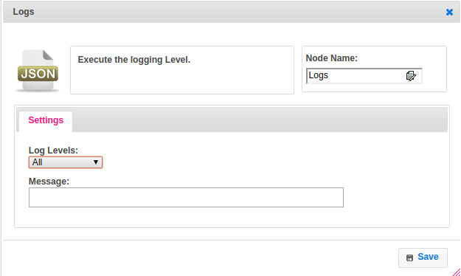

**Executor Description:**

It logs the message using log4j api based on the selected level.